Noughts and crosses

Contents

Analysis 1

Design 2

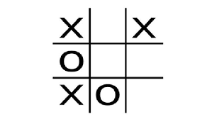

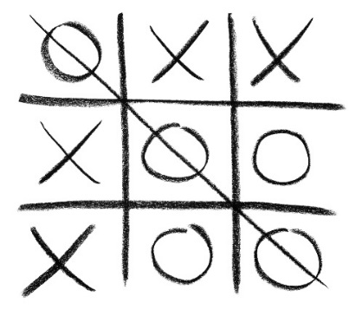

# Analysis

The rules of noughts and crosses:

Noughts and crosses is a simple game, where there is a 3x3 grid where players can put in one of two tokens into each of the squares, an O or an X. Each player can place one token in any space on their turn, and they take it in turns playing. The objective is to get three tokens in a row, horizontally, vertically or diagonally, before the other player can. Players cannot place their tokens in a space that is already occupied by another token.

The AI:

The AI must actively attempt to try and win by placing three tokens in a row. However, it must also be able to recognise when the player is about to win, and block them when they have two tokens in a row. The AI could have different difficulties, to change the player experience based on their skill level.

Error checking:

The code should print an error and not crash when:

* The user tries to place a token off the grid
* The user tries to place a token in an occupied space
* The user enters an incorrect variable type

Objectives:

* Allow the user to choose the difficulty of the AI
* Allow the user to choose whether they move first or second
* Allow the user to enter token into the desired place
* The AI should adapt to what is on the board and choose their move in accordance with the difficulty setting
* The game should end when three tokens are in a row
* The game should show who won the game
* The game should end when the game is unwinnable for either side, should display a draw

# Design